Project Design Phase-II Technology Stack (Architecture & Stack)

|  |  |
| --- | --- |
| Date | 03 October 2022 |
| Team ID | PNT2022TMID15445 |
| Project Name | Project - Global Sales Data Analytics |
| Maximum Marks | 4 Marks |

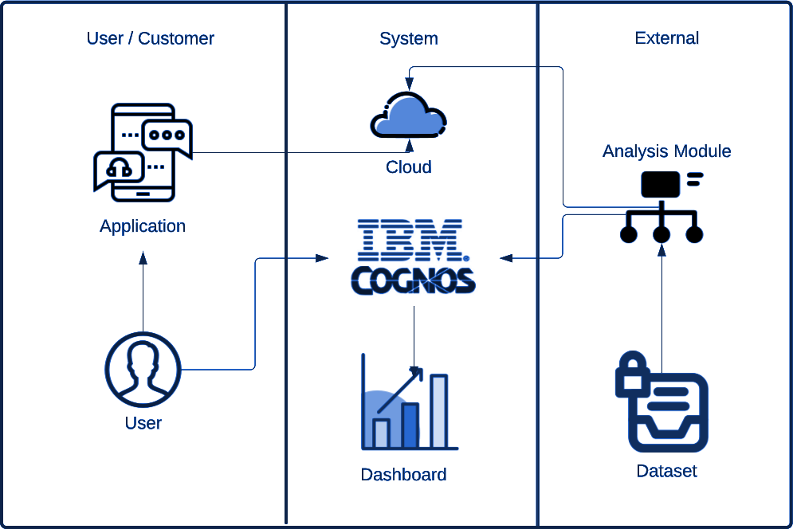

Table-1 : Components & Technologies:

|  |  |  |  |
| --- | --- | --- | --- |
| **S.No** | **Component** | **Description** | **Technology** |
| 1. | User Interface | How user interacts with application e.g. Web UI, Mobile App, Chatbot etc. | IBM Cognos |
| 2. | Storage Infrastructure (Cloud) | Customer sales data is uploaded in cloud through  interface | IBM Cloud |
| 3. | Working with Dataset | Uploading, Cleaning and Processing dataset | IBM Cognos + IBM Cloud |
| 4. | Data Exploration | Uploaded data is explored to identify trends | IBM Cognos |
| 5. | Data Visualization | Multiple types of graphs are shown according to customer data and requirements | IBM Cognos Dashboard |
| 6. | Cloud Database | Database Service on Cloud | IBM DB2, IBM Cloudant etc. |
| 7. | Viewing Data | User logins to application to view visualizations for uploaded data | IBM Cognos Dashboard |

Table-2: Application Characteristics:

|  |  |  |  |
| --- | --- | --- | --- |
| **S.No** | **Characteristics** | **Description** | **Technology** |
| 1. | Open-Source Frameworks | List the open-source frameworks used | IBM Cognos, IBM Cloud, IBM Watson |
| 2. | Security Implementations | Secure user information and data | Active Directory |
| 3. | Scalable Architecture | Supports various data sizes | Web 3.0 IBM Cloud |
| 4. | Availability | Multi page layout providing various visualizations of data and provide full support irrespective of  platform and device specifications | Cognos Business Intelligence Server |
| 5. | Performance | Withstand huge data and process them without crashing | IBM Cognos, Performance Management Hub |